Student Access to Blackboard

1.Open either Internet Explorer or Netscape Navigator on your computer  2. Click the Blackboard icon on the Bucknell home page,  -OR-  Go to www.bb.bucknell.edu  4. On the login screen enter your user id and password as were mailed to you. The user name is the first field of your email address, e.g., if your email address is vangogh@bucknell.edu, your user name is vangogh. The password is the 8 character password that was mailed to you. If you have forgotten your password, click the forgot your password link; you will receive email with instructions on how to reset your password. | 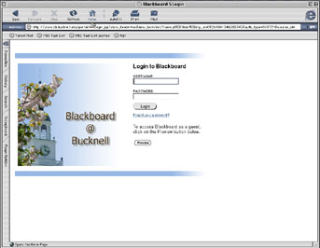

5. A new page will open. Scroll down the page to the My Courses panel, and click on the course that you wish to access.
6.You now have access to the course. The buttons on the left allow you to navigate through Announcements, Course Information, Staff Information, Course Documents, Assignments, Communication, External Links, and Tools.

