Faculty Access to Blackboard

1.Open either Internet Explorer or Netscape Navigator on your computer  2. Click the Blackboard icon on the Bucknell home page,  -OR-  Go to www.bb.bucknell.edu  4. On the login screen enter your user id and password as were mailed to you. The user name is the first field of your email address, ex., if your email address is vangogh@bucknell.edu, your user name is vangogh. The password is the 8 character password that was mailed to you. If you have forgotten your password, click the forgot your password link; you will receive email with instructions on how to reset your password. | 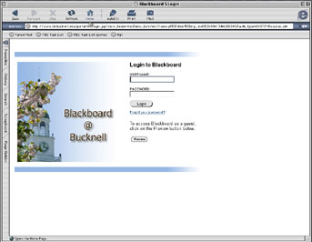

5. A new page will open. Scroll down the page to the My Courses panel; you will see a list of courses that you are teaching this semester All new courses are initially "inactive" which means that only you as the instructor can see them. Your students can not see these courses until they are activated. If the course has not been activated, under the course name you will find the label "unavailable".
6. To activate a course
- click on the course name
- When the course displays, click on the "Control Panel" button on the left side of the screen.

- In the Control Panel under Course Options, click on Course Settings.
- Click on "Course Availability"

- Click on "Yes" then click on the "Submit" button.
- Your course is now available to your students

