For Faculty, we have replaced the “My Courses” module with a new module that will organize your courses by semester. By default, this module will only display the current semester, similar to the following

To add other semesters to your view of My Courses, click on the pencil icon in the upper left corner. The following window will be displayed. The column on the left shows courses that will be displayed in your M Courses module. The column on the right shows all your courses.

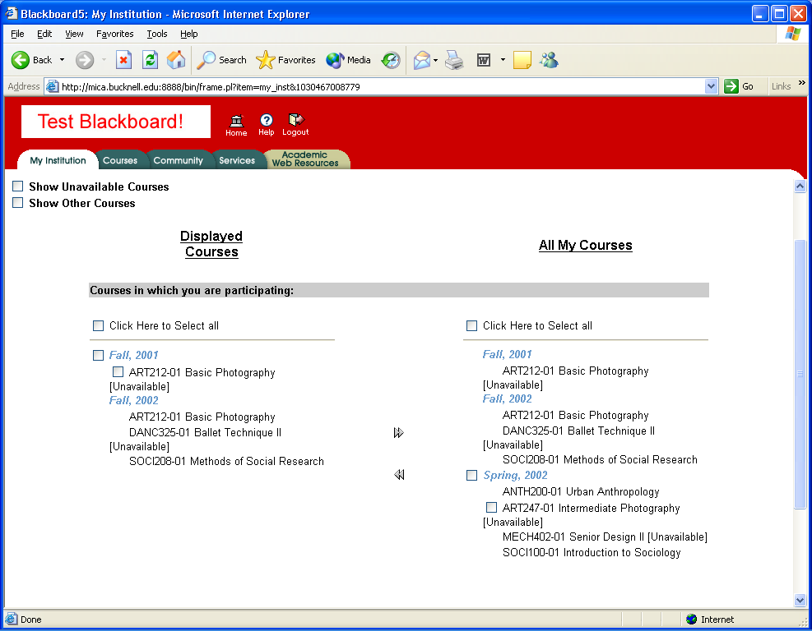

To add other semesters to the displayed side, click on the box associated with that semester, and click on the left arrow. To display “unavailable” courses, click on the “Show Unavailable Courses” box. To view “other” courses (that is, courses not associated with a particular semester) click on the “Show Other Courses” button.

When done, click on the Submit button.

The change to the My Course module also changes it’s location in My Institution. You can control the layout of the My Institution page by clicking on the “Content” button in the upper-right corner.

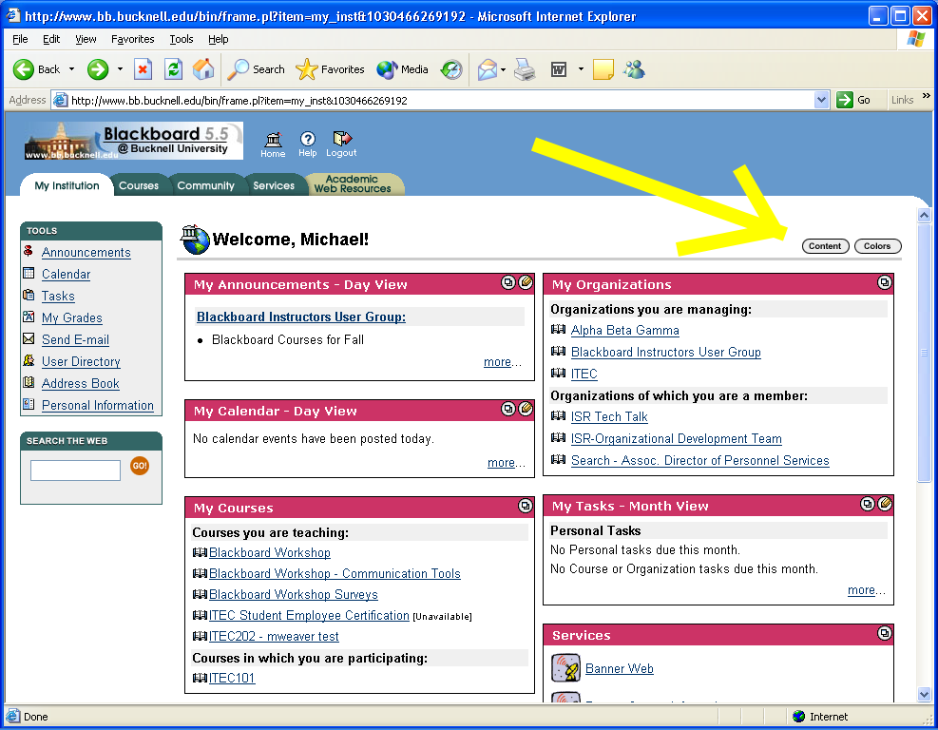

The following page will be displayed. This page lets you move things from the left to the right side and reorder them within the side. Items with an asterisk next to them are required. When done, click on the submit button.

